Pre-Camp Training Information

There are two sections to Camp Sequoia’s Pre-Camp Trainings. Please complete these modules before arriving to in-person training. We do recommend taking notes.

Kahoot Trainings
The following modules cover core areas for understanding our campers, systems, and administrative knowledge at camp. These can be done at your own pace, and you can take breaks between lessons. To access them, please do the following steps:
- Click on the link (laptop, computer, or tablet recommended, but can be done on a mobile device. Safari is not recommended, as it has challenges loading for some users.)
- When you first access, it will ask for account information. You do not need to make an account to complete the modules. You can continue as a guest without issue.
- It will prompt you to set your site Cookie settings. Choose the settings you are most comfortable with to continue.
- You will see a screen that looks like either of the following. Click the gray “Start” button to begin the module.
Desktop:  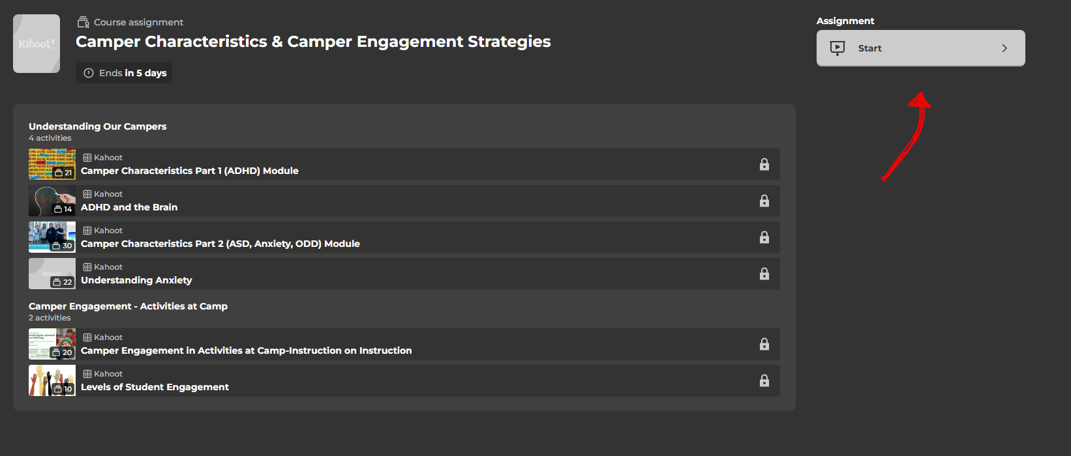 | Mobile:  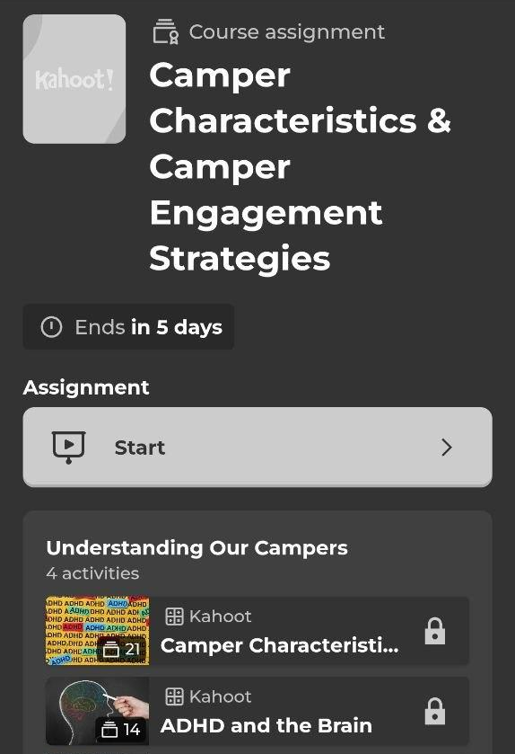
- You will be prompted to enter your “Nickname” and email. Please enter your full name (First and Last Initial) so we can ensure your results are counted as complete.
- Complete the modules before arriving at training. We recommend taking notes, as this information will be directly referenced in our in-person training sessions. There are 5 total modules. We recommend setting aside 4-6 hours in total to complete these modules. You can follow the links below:
- Camper Characteristics & Engagement
- Behavior Management and Social Skills Support
- Risk Management & Administrative Knowledge
- Sexual Harassment Module
- Leadership Team Knowledge & Administrative

7 Cup Modules
These (8) modules allow you to get research-based information through multimedia assessments on various issues that may impact campers that we serve. We recommend taking notes on these as well.
- Acceptance & Commitment Therapy
- Anxiety
- Social Anxiety
- Bullying
- Depression
- Managing Emotions
- Loneliness
- Psychological First Aid (PFA)

